**Monitoring Windows OS with Prometheus**

## Downloading Windows Exporter

## Installing Windows Exporter

To verify whether Windows Exporter is working, open a web browser and visit http://localhost:9182/metrics. If you see the following output, then Windows Exporter is working.

## Adding Windows Exporter to Prometheus

## Prometheus is running

IP address of your Windows computer

192.168.50.74

## Prometheus YAML file:

Now, visit the Prometheus Targets page at http://192.168.3.149:9090/targets from your favorite web browser, and you should see that the win10 target is in the UP state. It means that Prometheus can scrape stats from the Windows computer using Windows Exporter.

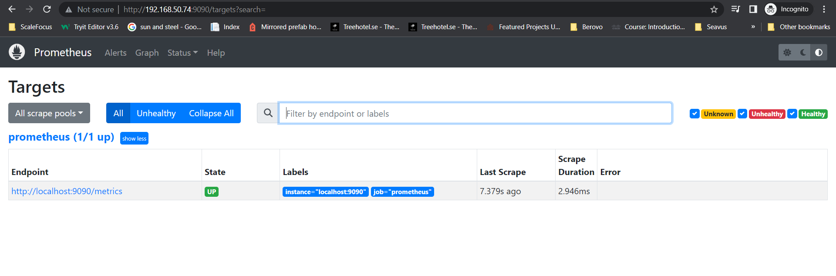

I was missing the Windows job, so I proceeded with restarting Prometheus.

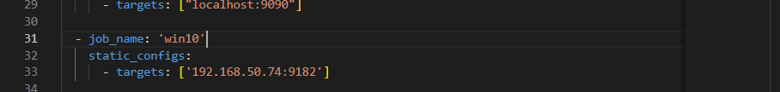

Installing Grafana, just for fun😊

Grafana is Installed

Changes to the yaml file:

Grafana: <http://localhost:3000/?orgId=1>

Prometheus: <http://192.168.50.74:9090/targets?search=>

Windows Exproter: <http://192.168.50.74:9182/>

## Setting up a Grafana Dashboard

Addint a Node Exporter dashboard

Importing the Dashboard ID

The previous one did not work for my windows machine. Set up another dashboard.

The dashboard is set:

